**WRITING TASK 1**

You should spend about 20 minutes on this task

**The table below shows the weight of people in a particular country from 1999 to 2009.**

Write at least 150 words.

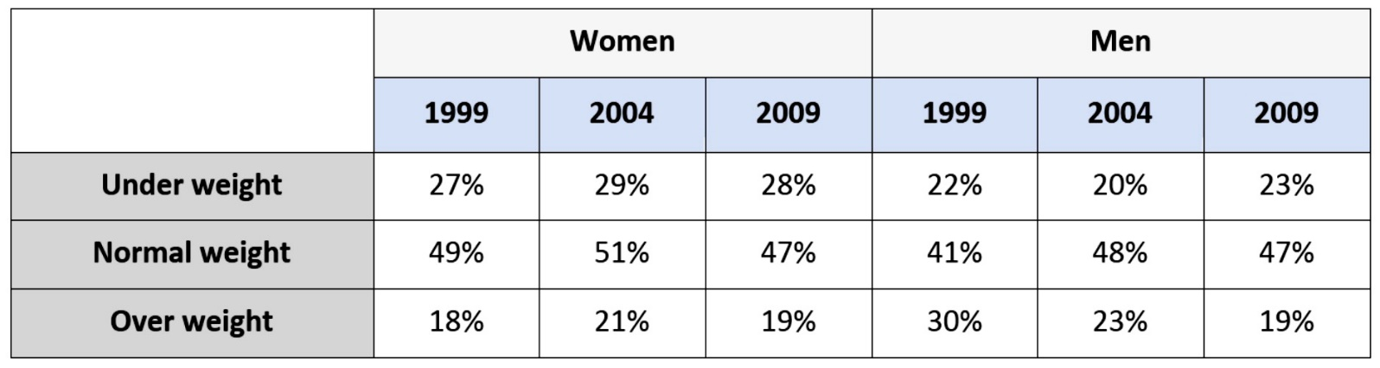

**WRITING TASK 2**

You should spend about 40 minutes on this task

Write about the following topic:

**These days people in some countries are living in a “throw-away” society which means people use things in a short time then throw them away. Causes and problems.**

Give reasons for your answer and include any relevant examples from your own knowledge or experience.

Write at least 250 words.